DAILY AQI OF CAAQM STATIONS IN BENGALURU (September-2021)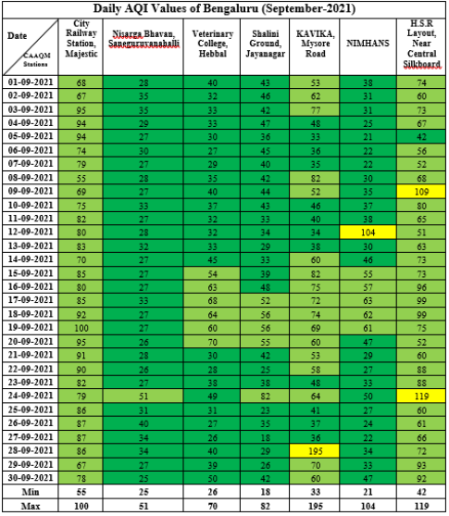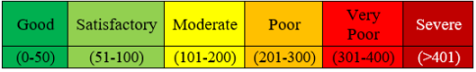
AQI Trend in CAAQMS, Bengaluru September 2021
